FTP Access to Web Server

1. Install CyberDuck FTP application.
2. Create a new bookmark.

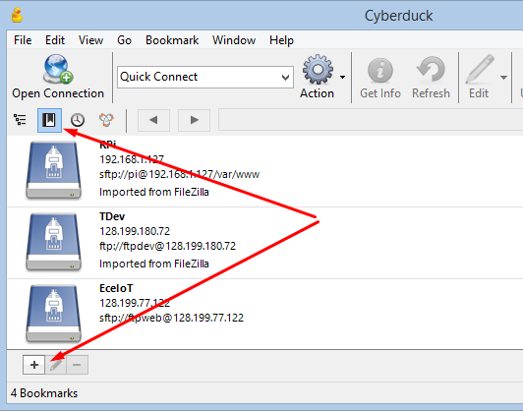

1. Set the bookmark to point to EceIoT server.
   1. Connection: SFTP
   2. IP: 128.199.77.122
   3. Username: ftpweb
   4. Password:

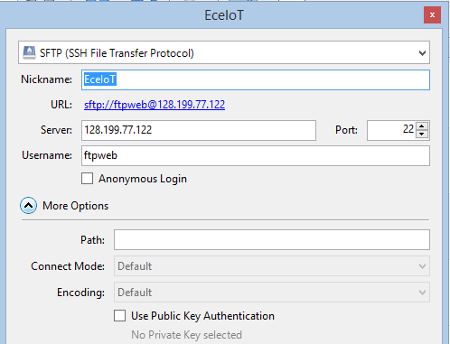

1. Look for project “publiccamera” folder under path “/var/www/html”.

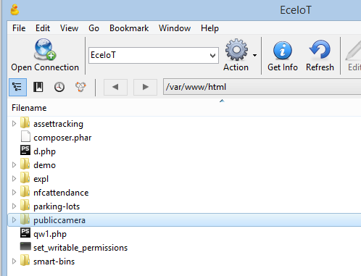

1. Folder structures

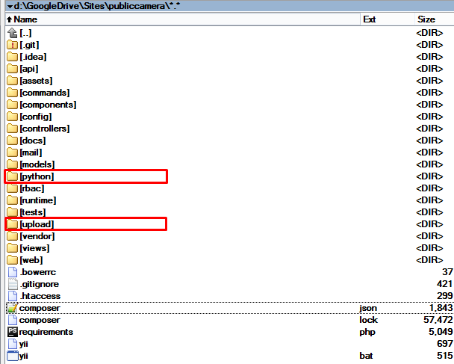

* 1. “**python**” folder – contains python scripts used by web server.

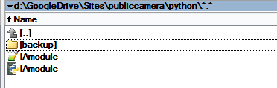

* 1. “**upload**” folder – image files
     + “files” folder contains image files uploaded by pi modules.
     + The file format is <node_id>_<yyyymmdd>_<hhmmss>_<random>

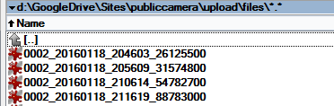

* + - “reference” folder contains reference image files for each node.
    - The file format is <node_id>

